Documentation
This document outlines the steps to connect to the team server, access shared resources and use the linux server to access the demo ap and dashboard.
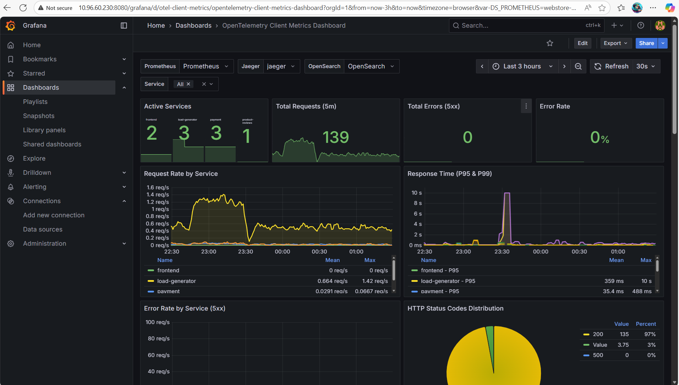
Steps to connecting to server:
Open your browser and direct to https://vpn.kennesaw.edu
Log in with your ksu credentials and download appropriate VPN based on your system.
Once downloaded, open it and put vpn.kennesaw.edu on the portal input to connect.
For Admin Access
ssh administrator@10.96.60.230
Password: linuxadmin

For Team shared folder
ssh first-name@10.96.60.230
** first name as in (daniel, kian, jay, or dakobie)
Password: linuxuser

** Created shared workfolder so our team can work on it without affecting the admin server.
ssh first-name@@10.96.60.230
password: linuxuser

**From any computer connected to the vpn.
Main Demo app Frontend: http://10.96.60.230:8080
Grafana: http://10.96.60.230:8080/grafana
* grafana username: admin
* grafana password: Danielekema#7

Once in Grafana, our prototype is in an OpenTelemetry Client Metrics Dashboard.
These are already configured and pulling data.

To leave the connection to the server, on PowerShell, enter in...
Exit

